Beauty  Makeover  Checklist  This multiple choice checklist should be completed to help determine which program (free or paid) is right for you. Avoid beginning a program without finishing this first, as it helps determine direction. You should know what you want your final body to be like before you begin making changes.  The first available answer choice to each inquiry is there on purpose! It yields the most feminine appearance, with second option yielding the next closest feminine appearance. This is a fool-proof questionnaire. If you don’t know what you are doing or what you want, you should select the first option to every question.  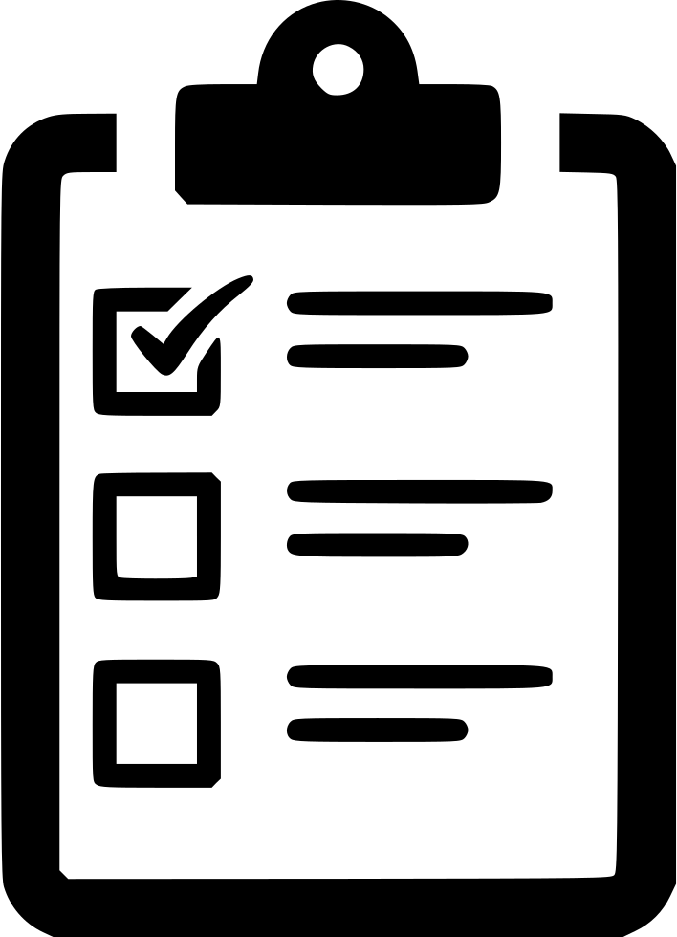 | 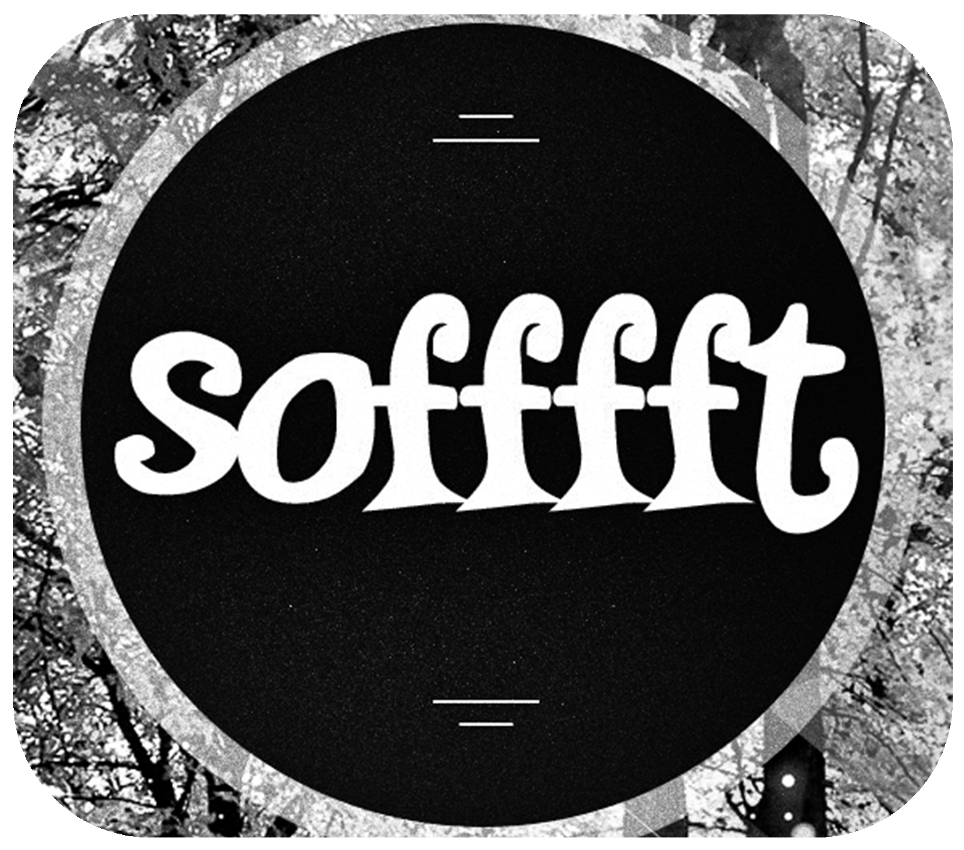    http://www.sofffft.com
Thigh size: (small) (medium) (large)
Thigh composition: (fat) (fat/muscle) (muscle)
Bicep size: (small) (medium) (large)
Bicep composition: (fat) (fat/muscle) (muscle)
Belly: (flat) (contour lines) (abs visible)
Waist: (hourglass figure) (contoured in) (flat with side of body)
Forearm size: (small) (medium) (large)
Calf size: (small) (medium) (large)
Calf composition: (fat) (fat/muscle) (muscle)
Breast size: (C cup) (B cup) (D cup) (A cup)
Breast composition: (soft not firm) (soft firm) (hard firm)
Thigh gap: (4-finger) (2-finger) (no gap)
Butt: (medium) (small) (large)
Butt composition: (soft not firm) (soft firm) (hard firm)
Trapezius size: (no rise) (slight rise) (triangle)
Neck size: (small) (medium) (large)
Cheek bones: (sticking out) (visible) (smooth with cheeks)
Shoulders: (not visible) (visible ball) (medium size ball)
Hands: (straight line slim contour) (straight slim with no knuckles visible) (straight slim with knuckles visible)
Arms: (slight contour) (straight stick) (mild contour)
Legs: (slight contour) (straight stick) (mild contour)
Vulva: (some lip hang) (compact smooth) (some camel-toe)
Bone visibility: (visible) (highly visible) (not visible)
Skin tan: (slight tan) (no tan) (dark tan)
Balance: (excellent) (good) (fair)
Teeth whiteness: (white) (extra white) (moderately white)
Skin complexion: (smooth) (some imperfections)
Sex appeal: (high) (medium) (unconcerned)
Vaginal tightness: (tight) (medium tight ripple waves) (medium tightness)
Walking stride: (medium) (long) (short)
Attractiveness: (high) (medium) (unconcerned)
Silhouette: (peak) (high) (unconcerned)
Tallness: (somewhat tall) (tall) (shorter)
Eye size: (large) (medium) (small)
Body strength: (not strong) (mild strength) (decent strength)
Posture: (vertical, shoulder back) (vertical) (improved)
Arm sway: (attractive sway) (confident appearance) (no change)
Walking appearance: (hip sway and tilt) (hip sway) (no change)
Ending flexibility: (high) (moderate) (low)
Method preferred: (no exercise) (active lifestyle) (excessive exercise)
Achievement time-frame: (long) (medium) (short)
Eye glasses: (no eyeglasses needed) (I don’t want eyeglasses/contacts anymore) (indifferent)
Collarbones: (visible) (sticking out) (not visible)
Hipbones: (visible) (sticking out) (not visible)
Appearance: (small and endowed) (tiny and delicate) (medium and well endowed)
Fitness perception: (born sexy) (fit without gym time) (fit with gym time)
New you: (some improvements over my younger self) (like my younger self) (like a whole different person)
Dress: (form fitting clothes) (loose clothing)
Look: (sexy) (classy) (blend in)
Favorite clothing season: (Summer) (Spring) (Fall) (Winter)
Cheeks: (slightly sunken) (flat) (slight round)
Particulars: (I want maximum femininity/sexuality) (I want as skinny as possible) (very particular end look)
Ribs: (visible) (sticking out) (not visible)
Forearm shape: (slight contour) (straight stick) (straight into contour)
Upper-arm shape: (straight stick) (slight contour)
Calf shape: (slight contour) (small muscle bulge) (straight stick)
Thigh shape: (slight contour) (straight stick) (medium contour)
Desired height: (slight height increase) (significant height increase) (unconcerned)

